Name | Subject Class | Class | Index Number
 | 2BI



ANGLO-CHINESE JUNIOR COLLEGE

Preliminary Examination 2021

BIOLOGY 9744/03

HIGHER 2 31 August 2021 Paper 3 Long Structured and Free-response Questions 2 hours

READ THESE INSTRUCTIONS FIRST

Write your name, subject class, form class and index number on all the work you hand in.
Write in dark blue or black pen.
You may use a soft pencil for any diagrams, graphs or rough working.
Do not use staples, paper clips, highlighters, glue or correction fluid.

Section A
Answer all questions in the spaces provided on the Question Paper.

FOR EXAMINER’S USE
1
2
3
4 or 5
TOTAL
75
Section B
Answer any one question on the separate writing paper provided.

The use of an approved scientific calculator is expected, where appropriate.
You may lose marks if you do not show working or if you do not use appropriate units.

At the end of the examination, fasten your work securely together.
The number of marks is given in brackets [ ] at the end of each question or part question.

This document consists of 15 printed pages.
Section A

Answer all the questions in this section.

- Fig 1.1 shows part of the reproductive cycle of the influenza virus in an infected cell.

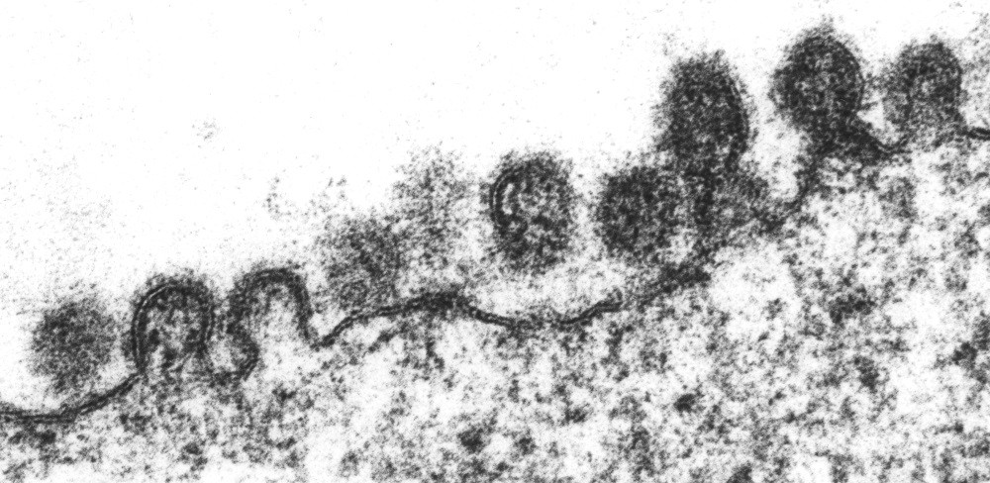

Fig. 1.1

- Describe the part of the influenza virus reproductive cycle shown in Fig. 1.1.
[3]

A study was carried out to determine the factors that affect the replication of influenza virus. In a single-cell analysis, one viral-infected cell was transferred to each well on a 384-well plate (Fig. 1.2). As the virus replicates in the cell, the viral particles are released from the cell into the well.

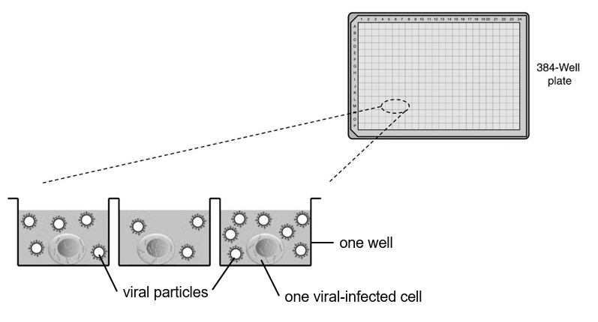
Fig. 1.2

To ensure that the cells placed in the wells are all infected by the influenza virus, the scientists also measured the infection of the cell and the state of the cell after exposure to the virus.

Fig. 1.3 shows the proportion of cells infected and the proportion of cells undergoing apoptosis on the plate.

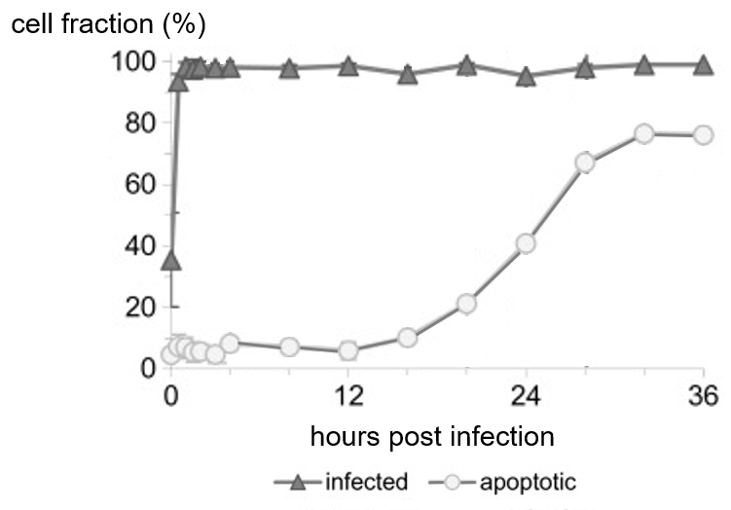

Fig. 1.3

The virus yield per cell, which is the number of infectious viral particles released from each cell, was determined. The diameter of each infected cell is also measured. The results are shown in Fig. 1.4a and Fig. 1.4b. The first bar on the left of the histogram in Fig. 1.4a indicates the fraction of cells that shows no release of viruses.

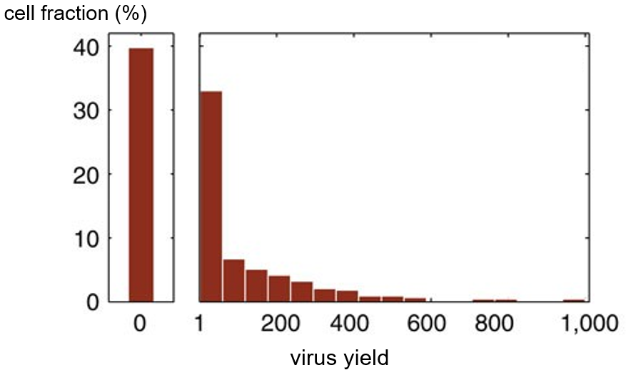
Fig. 1.4a

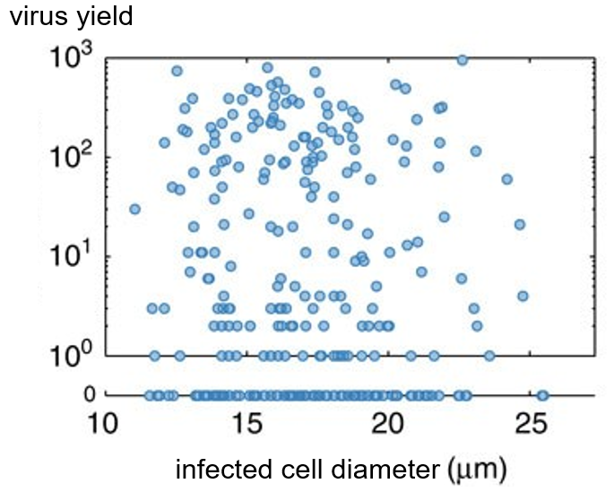
Fig. 1.4b

- (i) With reference to Fig. 1.4b, comment on the relationship between the diameter of the viral-infected cell and the virus yield.
[2]
(ii) Given the formula of the surface area of a sphere is 4πr², calculate the area of the cell surface membrane of a viral-infected cell with a diameter of 15 µm. Show your workings and present your answers in nm².
[2]

(iii) The average diameter of the viral particles released in the early phase of an infection is approximately 120 nm. Determine the maximum possible number of viral particles that can be released from a viral-infected cell with a diameter of 15 µm. Show your workings.
[2]

(iv) The observed maximum number of viral particles released from each viral-infected cell (Fig. 1.4a and 1.4b) differs from the maximum possible number of viral particles released (from calculations in (b)(iii)).

With reference to all the information provided, suggest a reason for this difference.
[3]

Fig. 1.5 shows the structures of sialic acid and two antiviral drugs, Zanamivir and Oseltamivir. Both antiviral drugs target neuraminidase (NA).

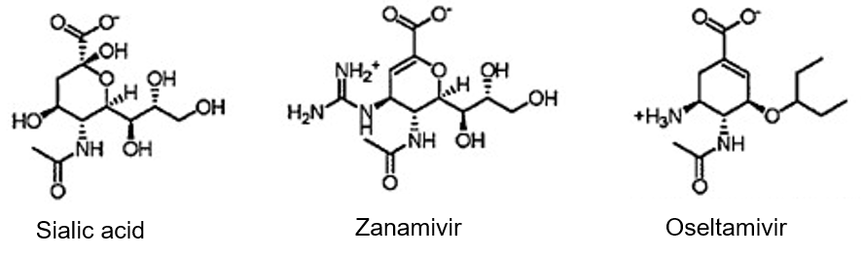
Fig. 1.5

- (i) With reference to Fig. 1.5, deduce how Zanamivir and Oseltamivir inhibit the action of neuraminidase.
[3]

(ii) Zanamivir is administered via inhalation, while Oseltamivir is a tablet that is taken orally. Suggest an advantage of administering the antiviral drug via inhalation.
[1]

It is uncommon for humans to be directly infected with avian flu virus and for the infected human to transmit the virus to another human. This is termed as “host restriction”.

Transmission typically requires an intermediate host, often referred to as a “mixing vessel”, in order for new viruses to cross the species boundaries from birds to humans (Fig. 1.6).
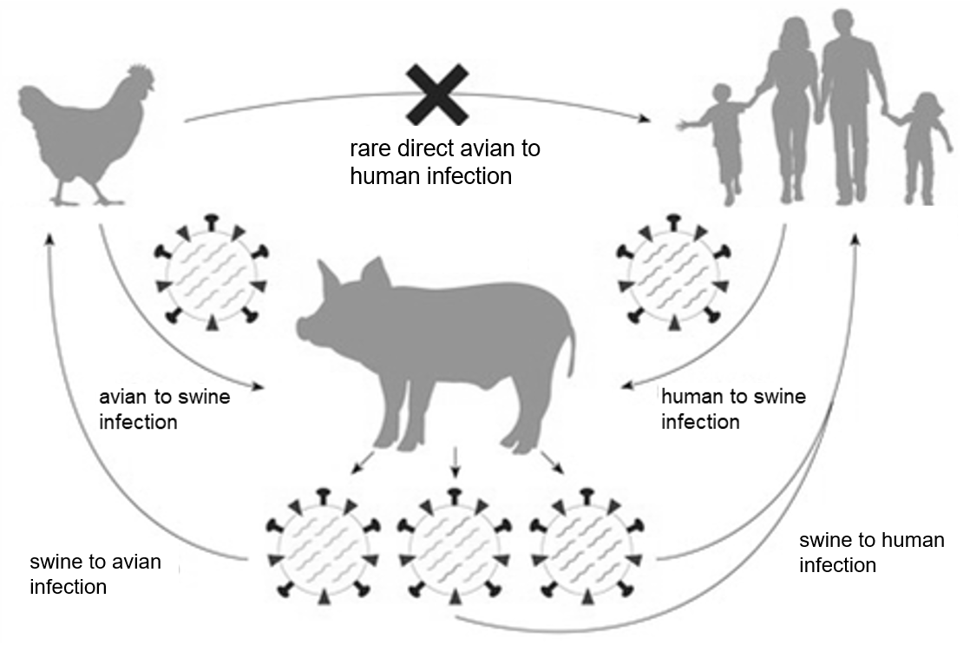
mixing vessel

Fig. 1.6

Host restriction of each influenza virus is the result of the interaction between its haemagglutinin (HA) and a specific sialic acid receptor found on the specific host cell. The type of sialic acid receptors found on the different host cells is shown in Table 1.1.

Table 1.1

Type of host cells | Type of glycosidic bond found between the last sialic acid to the oligosaccharide chain on the cell surface glycoprotein
Human | α 2–6 linkage
Avian | α 2–3 linkage
Swine | α 2–3 linkage and α 2–6 linkage

- (i) Outline the synthesis of the sialic acid receptors in the host cells.
[2]

(ii) Suggest why swine is suitable as a “mixing vessel” that allows a virus to cross the species boundary from birds to humans.
[3]

- Explain how specific features of the influenza genome allow variation in the viral genome to arise over time.
[4]

Scientists study the evolution of influenza viruses so as to predict new viral variants and design vaccines. One way to study the evolutionary history of the viruses is through phylogenetic analysis of viral genetic sequences such as the HA gene. Fig. 1.7 shows the phylogenetic relationships between the 18 different HA subtypes (H1 to H18). Group 1 HA polypeptide molecules share a highly conserved amino acid sequence, which is different from that shared among the Group 2 HA molecules.
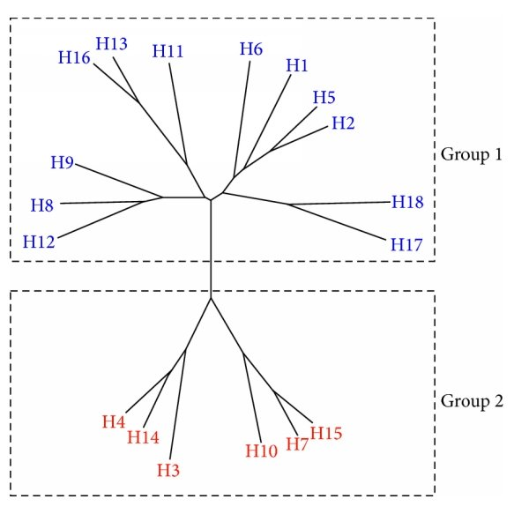
Fig. 1.7

- Using the information provided, explain how a named selection pressure can result in the evolution of influenza viruses.
[4]

[Total: 29]
- Fig. 2.1 shows the levels of Mycobacterium tuberculosis (also known as bacterial burden) in an infected person, measured using bacterial antigen levels in the bloodstream. The patient received treatment for the disease which was administered orally, but a repeated treatment was required when the first treatment proved ineffective.
Bacterial burden
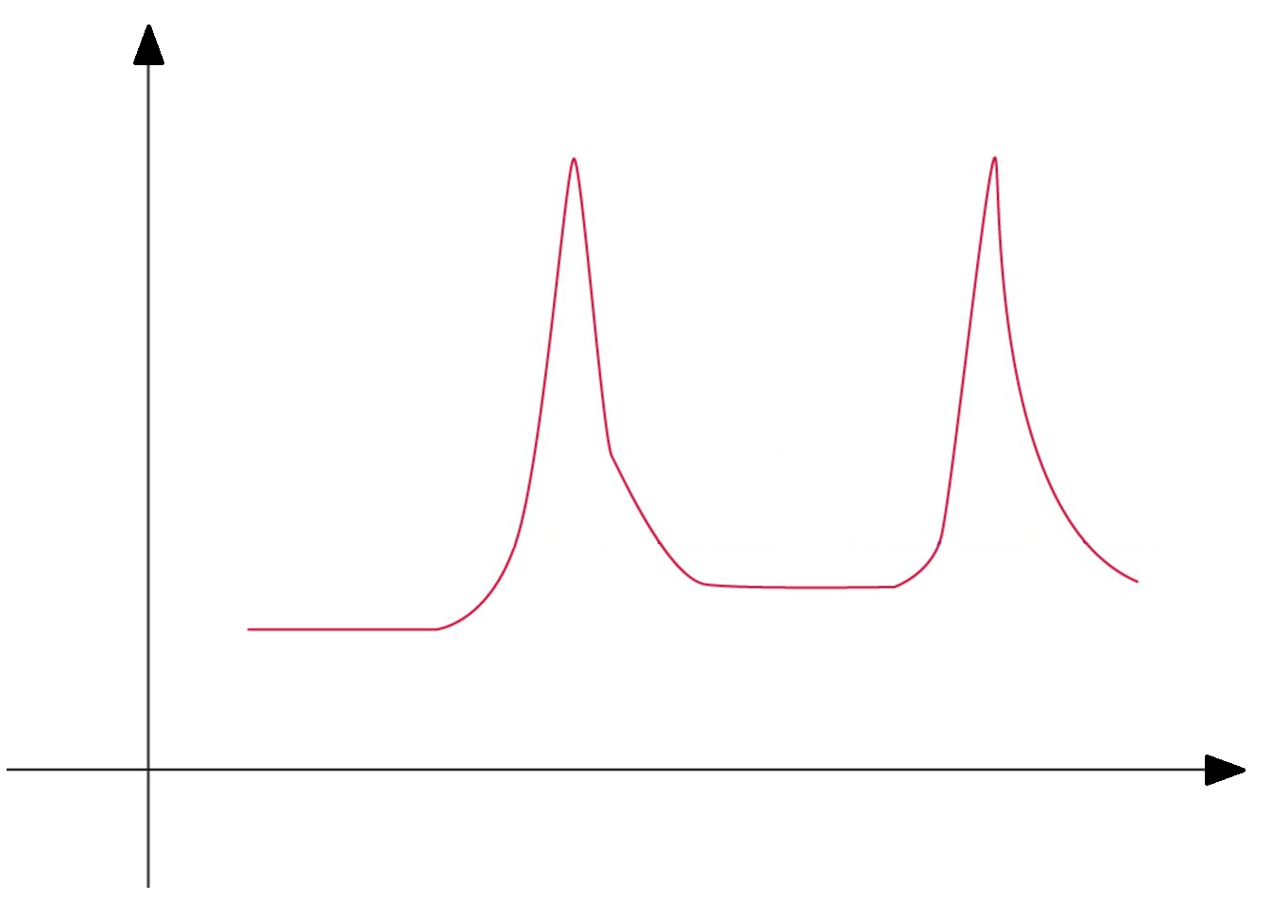
X
First Treatment
Repeated Treatment
Time

Fig. 2.1

(a) (i) With reference to Fig. 2.1, account for the changes in bacterial burden during the time period labelled X.
ori
ori
[5]
(ii) Deduce the likely treatment that the patient received and describe one possible mechanism of this treatment.
[2]

(iii) Suggest why the treatment administered may be ineffective in curing the infection.
ori
ori
[1]

It has long been believed that antibody responses have a limited effect on an infection by Mycobacterium tuberculosis.

(b) With reference to one function of antibodies, explain the reason for this belief.
[2]

[Total: 10]

- The behaviour of animals is determined by both their genetic make-up and the environment in which they are in.

(a) Explain how both the genetic make-up of animals and the environmental conditions they live in determine their behaviour.
[3]

The introduction and establishment of non-native species often changes the ecological relationships in the recipient ecosystem. The northern pike (Esox lucius) is an example of a non-native species of fish that has been introduced into some large lakes in America. This fish feeds mainly on invertebrates, but when a suitable fish prey is available, it becomes piscivorous (feeds on fish). One species of fish that the northern pike feeds on is the brown trout (Salmo trutta).

Fig. 3.1a shows the effect of temperature on the attack rate of northern pike on its prey, brown trout. The attack rate reflects the frequency at which northern pike searches for the brown trout. Two groups of northern pike were subjected to either a short or long starvation time. Fig. 3.1b shows the effect of temperature on the swimming speed of northern pike and brown trout.

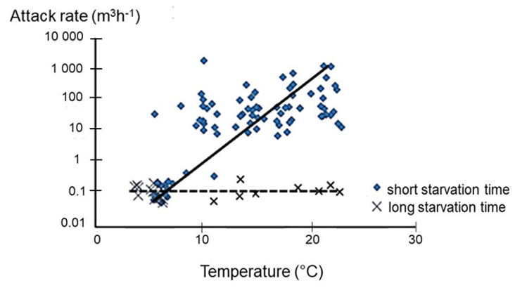

Fig. 3.1a

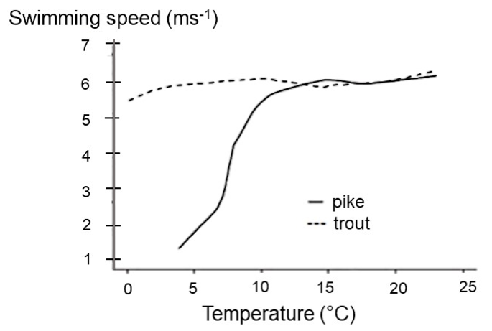

Fig. 3.1b

(b) (i) Describe the effect of temperature and starvation time on the attack rate of northern pike.
[4]

Brown trout thrives in Lake Michigan, one of the five great lakes of North America. Lake Michigan is the second-largest of the great lakes in America and spans 494 km long and 190 km wide with the greatest depth of 281 m. The surface temperature of the lake surface averages 20°C, while the temperature of the lake drops on an average of 2.5°C for every 500 m.

When northern pike was introduced into Lake Michigan, the population of brown trout decreased.

(ii) Calculate the expected water temperature at the deepest part of the lake. Show your workings.

[2]

(iii) Using the calculated temperature in (b)(ii) and data provided in Fig. 3.1a and 3.1b, predict the likely effect of increasing temperature on the behaviour of the two species of fishes.
[2]

[Total: 11]

Section B

Answer one question in this section.

Write your answers on the separate writing paper provided.

Your answers should be illustrated by large, clearly labelled diagrams, where appropriate.

Your answers must be in continuous prose, where appropriate.

Your answers must be set out in parts (a) and (b), as indicated in the question.

4 | DNA contains thousands of genes which code for proteins that dictate cell function. Gene expression is tightly controlled. The regulation of gene expression involves different biomolecules, and is important for cellular activities such as cell and nuclear division.
 | (a) | Describe how ribonucleic acids are involved in the flow of information from DNA to proteins. [15]
 | (b) | Describe the events that occur during interphase of the cell cycle in preparation for cell and nuclear division and explain why it is important to regulate these events at appropriate time points. [10]
 |  | [Total: 25]
5 | Two groups of genes are involved in regulating the cell cycle, where the actions of the proteins of these two groups of genes counteract each other to achieve a balance between cell division and cell death. Mutations, which either affect individual genes or large segments of the chromosome, may lead to the development of cancer.
 | (a) | Explain how mutations affecting the two groups of genes involved in cell cycle regulation may lead to the development of cancer. [15]
 | (b) | Outline the techniques by which mutations, either affecting individual genes or large segments of the chromosome, may be identified in an individual. [10]
 |  | [Total: 25]

[End of Paper]

